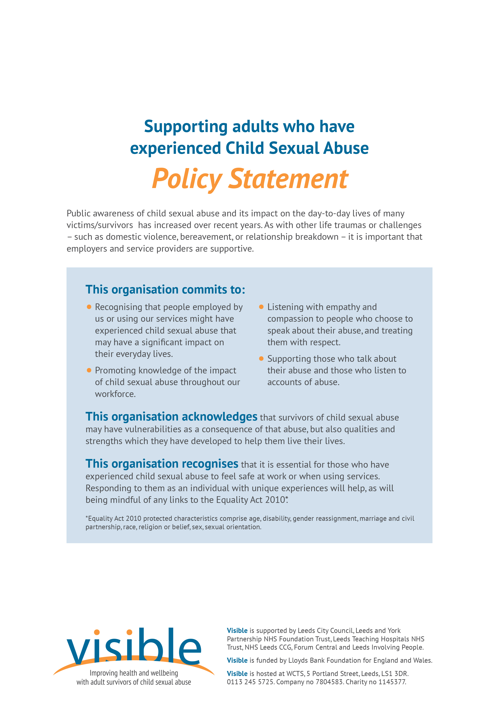

Commitment adopted by (insert organisation name) on (insert date) at the meeting of (insert meeting name) e.g. Commitment adopted by Women’s Counselling and Therapy Service on 14th November 2018 at the meeting of the Board of Trustees

Insert organisation logo here